1.Download multitiff folder from the tracker



Save locally on the computer.

2.Need to save this multitiff as a folder of single tiffs of each channel in order to preform (

Background removal)

Run the following matlab code that is found in MIBIanalysis:

MIBIsaveFolderOfMultiTiffsAsFolder.m

3. Now you get folder named ‘extracted’ with the tiffs of the different FOVs.

4. Save the extracted folder on the wexac and create a new folder named ‘info’

That will include an xml file and the panel csv file (download from tracker).

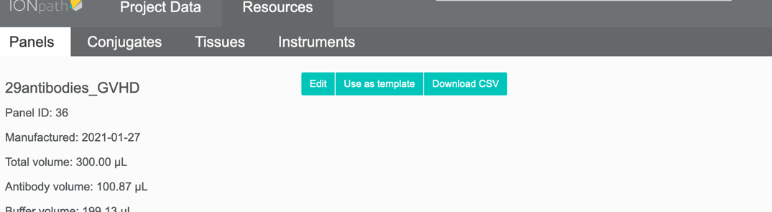

5. The panel needs to be changed a bit :

Delete the top part and Change ‘Target’ to ‘Label’

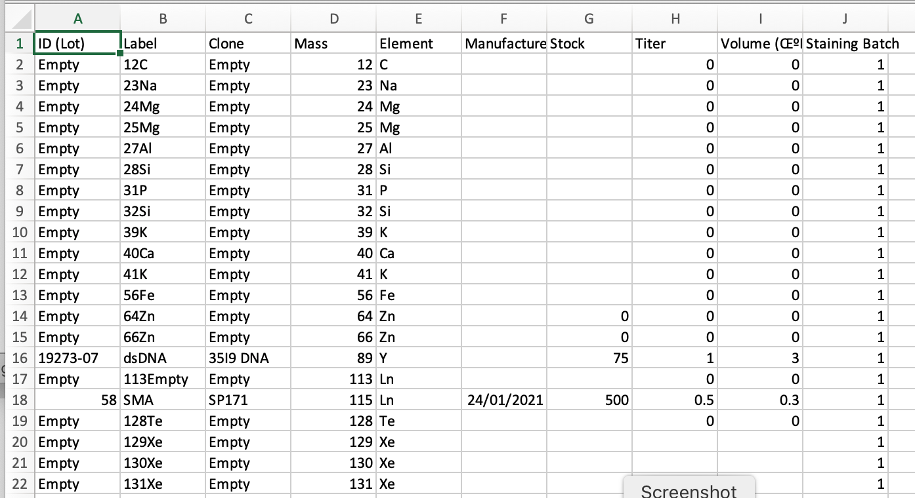

The Folder will look like this:

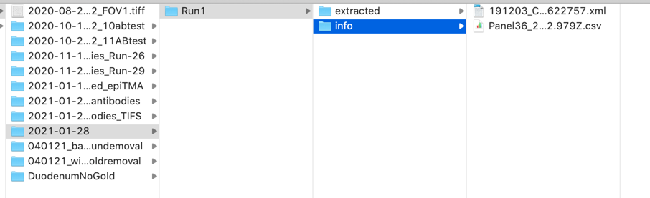

6. Now you can run background removal found in the Maui folder

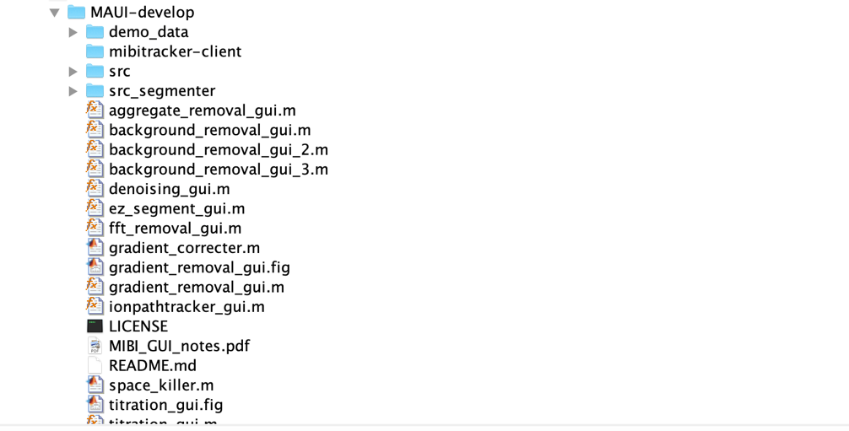

7.Background removal explanation leeat lecture on wexac.